Name: Parmar Kuldip Rupsangbhai

Roll No. CE080

Batch : B1

LAB-05

**3.**

**Code:**

<!DOCTYPE html>

<html lang="en">

<head>

<style>

body{

*margin*: auto;

*padding* :0;

}

.but{

*color*:white;

*background-color*: teal;

*border*: 2px solid black;

*border-radius*: 10px;

*box-shadow*:4px black;

*margin*:10px;

*height*: 40px;

*padding*:7px;

*text-align*: center;

}

.butpat{

*text-align*: center;

}

.dark{

*color*:white;

*background-color*: black;;

}

</style>

<meta charset="UTF-8">

<meta name="viewport" content="width=device-width, initial-scale=1.0">

<title>Document</title>

</head>

<body>

<div class="butpat">

<h2>Choose Your theme </h2>

<button class='but' id="butx"> Dark mode</button>

<button class='but' id="buty"> Light mode</button>

</div>

<script>

*let* x=document.getElementById("butx");

*let* y=document.getElementById("buty");

x.addEventListener('click',()*=>*{

document.body.classList.add("dark");

})

y.addEventListener('click',()*=>*{

document.body.classList.remove("dark");

})

</script>

</body>

</html>

**Output:**

Before:

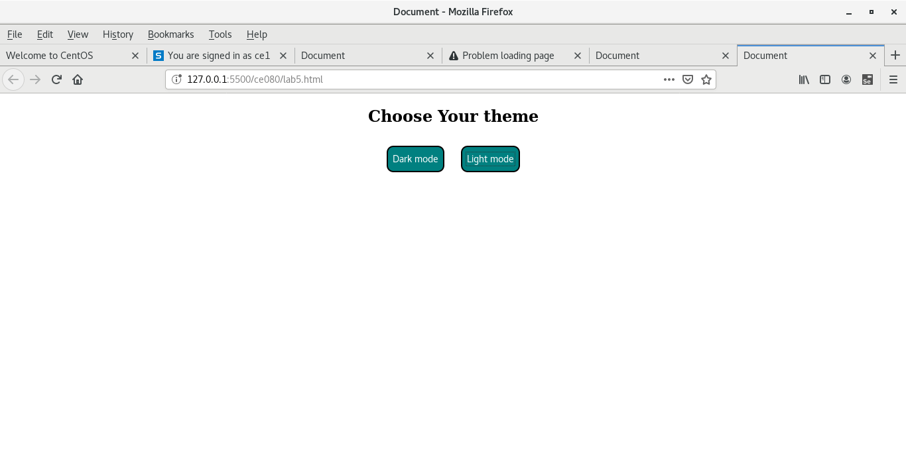

After:

